User Manual

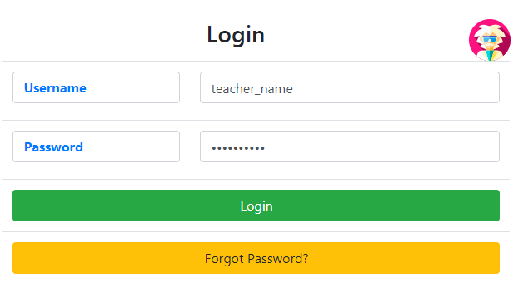

The starting page is a login page. You cannot do anything without logging in. So log in first.

The first time you log in, your password will be set randomly. You will have to click Forgot Password and change it.

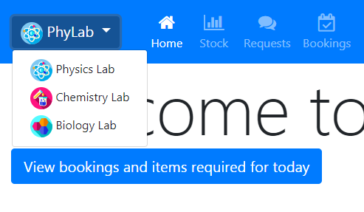

The navigation bar has a button called PhyLab. This stands for physics lab. You **MUST** choose the right lab *before you start your work*. The color of the navigation bar changes to remind you which lab you are in (blue – physics, red – chemistry, green – biology). The lab you are using can be changed at any time using the same dropdown.

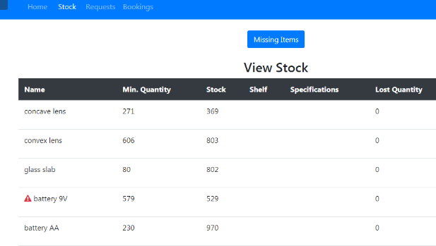

The stock tab lets you see all the available items in the lab you are in. This helps you plan ahead to make sure that you have what you need for your classes.

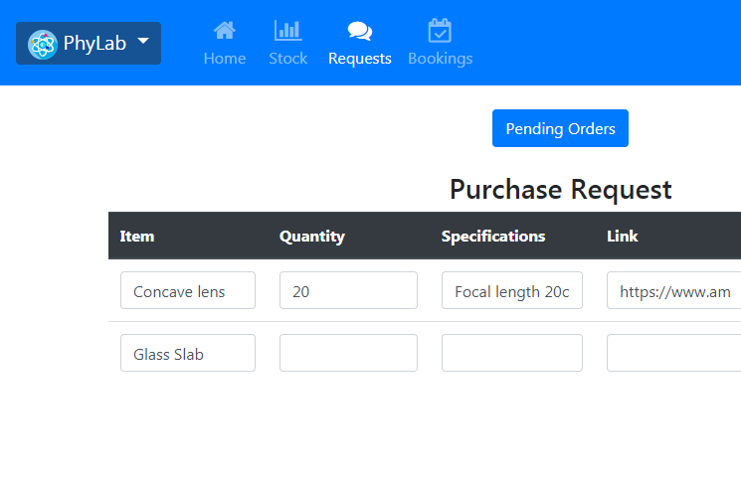

The request table allows you to put in a purchase request for an item. Click on ‘Add Order’ to add another row to the table, and ‘Place order’ to submit it. You MUST also provide a link and the approximate cost of your request. These requests are compiled periodically, usually around once a month (though this may change depending on the lab/lab in-charge). You will be notified by email when your shipment arrives.

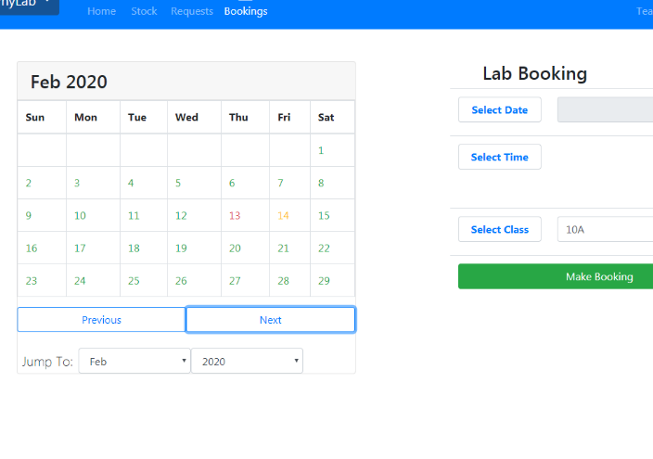

The bookings tab allows you to book the lab for a period of time, and also book the items that you will require so that these can be set aside. You can also use it to see when the lab has been booked and by who. The yellow days on the calendar mean that some slots are booked, while red days indicate a completely booked lab for the entire day.

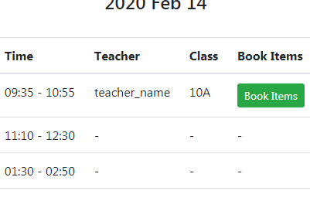

Once you book the lab, click on the day you have booked it and go to ‘book items’ book an experiment. This is mandatory so that the lab in-charge can set aside these items for you, and it also helps the school keep a record of all the experiments that were conducted in the lab.

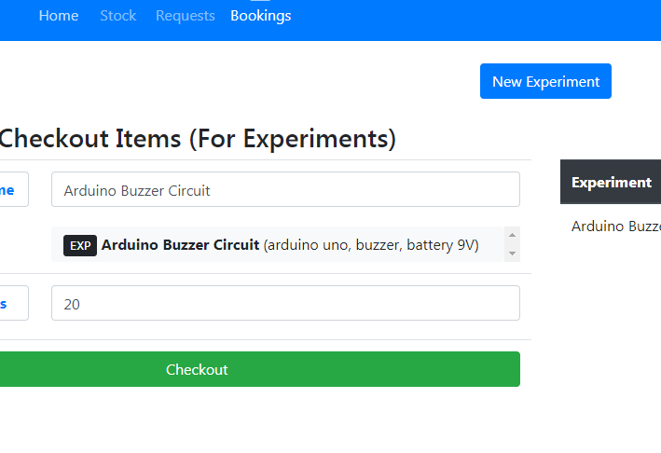

You can only book the items for a single experiment. If you are unable to find the experiment you are looking for, you can always create it yourself using the ‘New Experiment’ button.

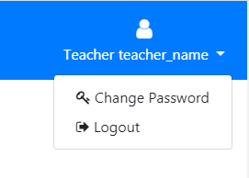

You can click on your username on the top right corner to logout or change your password at any time.